2025 Goals for Pakistan
Free families from debt servitude
Care and education for orphans
Childhood vaccination
Support needed medical care
Childhood nutritional support
Clean and safe drinking water
Safe housing for everyone
Education for all children
Celebrating precious children
2025 Proposed Budget
The projects we propose for 2025 come at a price. As a ministry, we must seek support to accomplish these noble goals. Here is the breakdown of our anticipated expenses:

Rain Academy $16,200.00
Dashoa Orphanage $13,500.00
Toba Tek Singh village $39,000.00
Administrative costs $7,300.00
Total 2025 costs $76,000.00

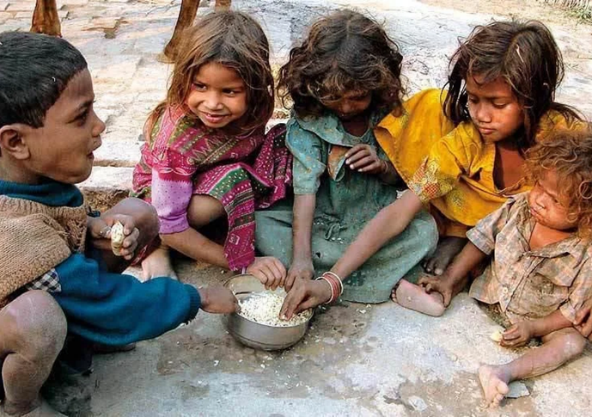
To accomplish these ambitious projects, we need to present our plan in front of churches or other organizations. Please help us reach your organization.
Organizational Overview
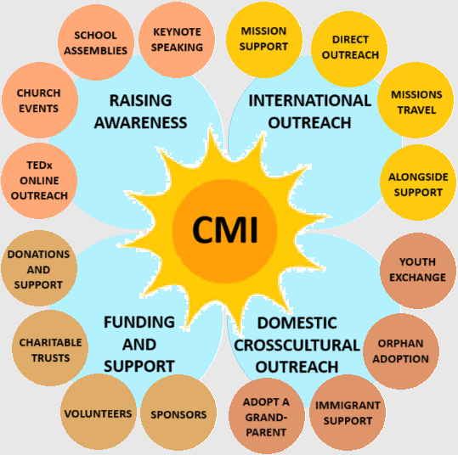

CMI’s mission is to help those among the poorest of the world’s poor gain freedom, access education and healthcare, over-come malnutrition and the risks of poverty and to ultimately reach out and grasp the opportunities to improve their lives through personal support.
Help needed:
Pray for our mission
Volunteer or donate
Share CMI
Join us on a mission
Help us present to your church/organization
Childrens Ministries International
www.childrensmi.org
aheart4childreneverywhere@gmail.com
4822 7TH AVE, TEMPLE, PA 19560
610-396-5942
We are a Pennsylvania registered 501-C(3)
A recognized NGO by the government of Pakistan
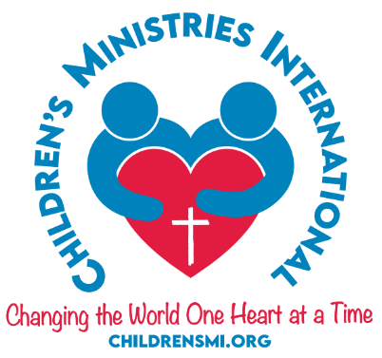
Serving in Pakistan
Pakistan Facts & Figures:
Pakistan is the fifth-most populated country in the world with 245 million people.
55 million Pakistanis live in families earning less than $10.00 per month.
Another 45 million people live in families earning less than $20.00 per month.
Many Pakistanis live in severe malnutrition, poor health, high childhood mortality, very limited access to education, and lack of a way out of this situation.
Your support will help them escape their dire situation.
Consider a mission trip with us – Missions change the lives of everyone involved one heart at a time.
Now these three remain: faith, hope and love, but the greatest of these is love.
2025 Mission Goals
Goal 1 - Free those in servitude
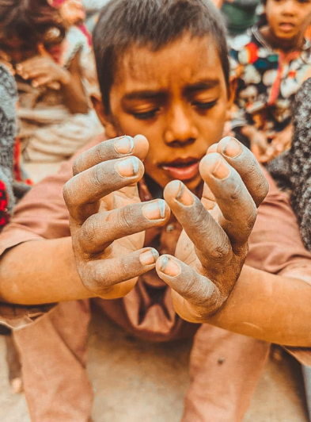
In Pakistan, when your parents are in debt servitude – you, too, are a slave. Debt is passed along generationally

Redeeming those in slavery

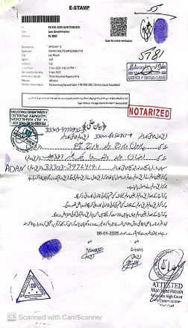
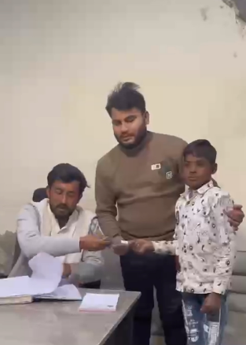

Goal 2 - Support Orphans

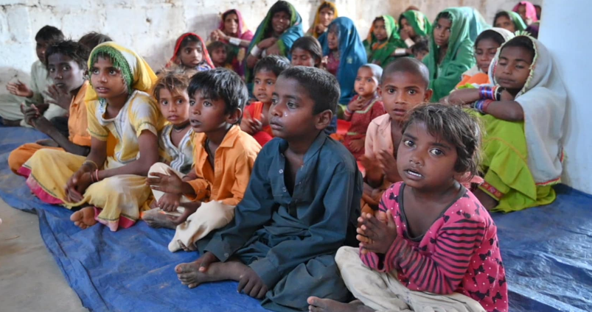
Goal 8 – Education for all
Orphaned children receive education
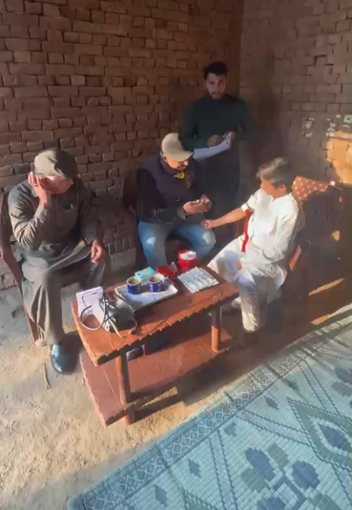
Goals 3/4 – Vaccination & Healthcare
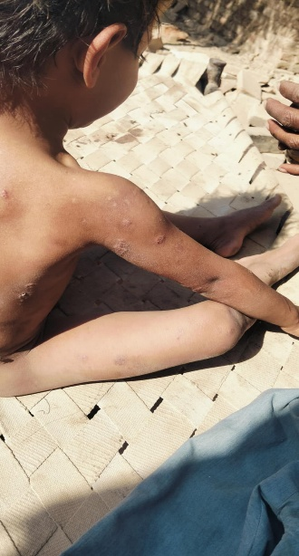
Childhood illness runs rampant among the poor. Diseases defeated long ago in the west remain costly and deadly. In some areas, up to 30% of children still die in childhood.
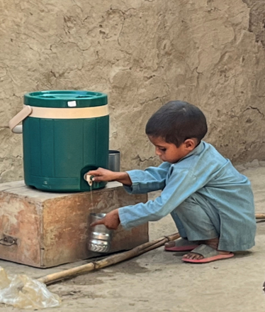
Goal 5 – Childhood nutrition
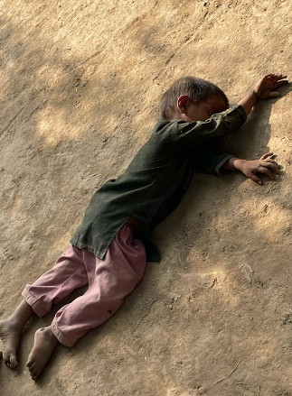
A child faints with hunger – no longer. Now children help themselves to PediaSure.
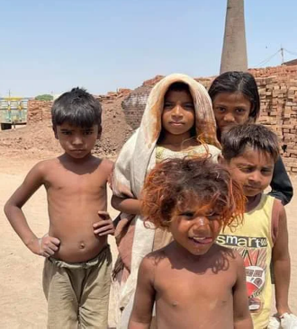
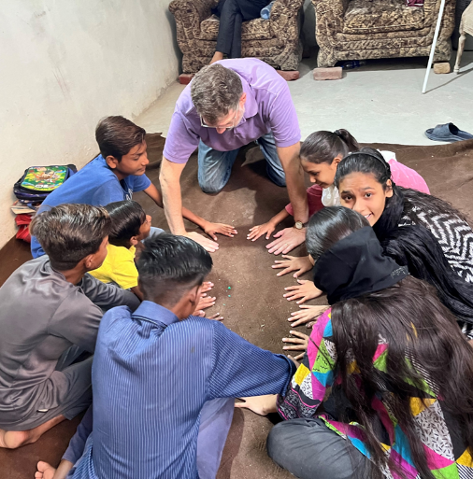
playing a game with students at Rain Academy

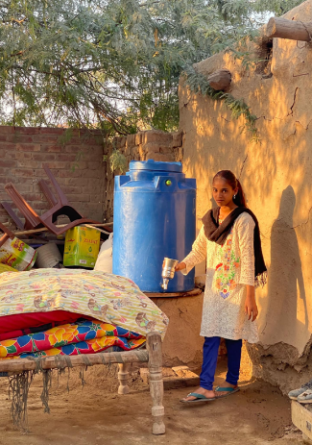
Goal 6 – Safe drinking water
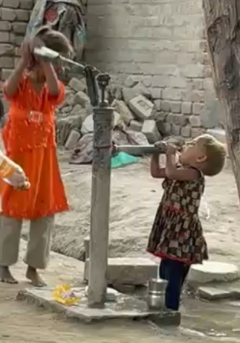
Waterborne illnesses account for a large number of childhood illnesses and fatalities Since CMI is working with this village, all have access to clean drinking water
Goal 7 – Safer Housing
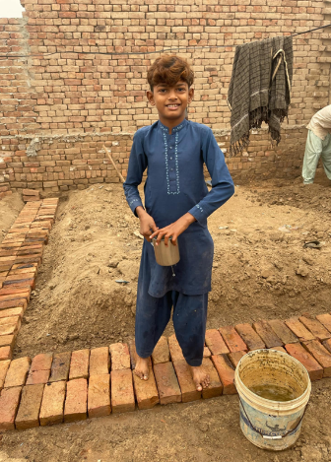
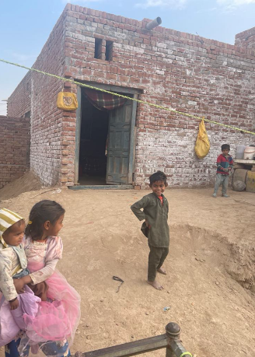
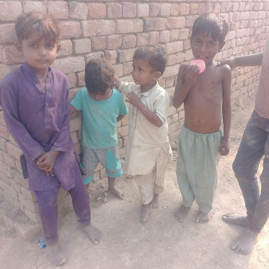
Replacing mud huts with stronger brick houses provides safety from collapse during the monsoon season.

